Merchandise & Prices

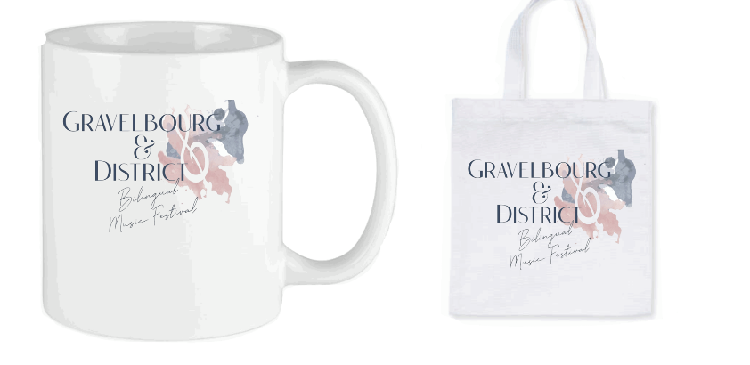
Mug: $20
Bag: $30

Insulated Travel Mug
Slim or Plump: $35

Water Bottle: $35
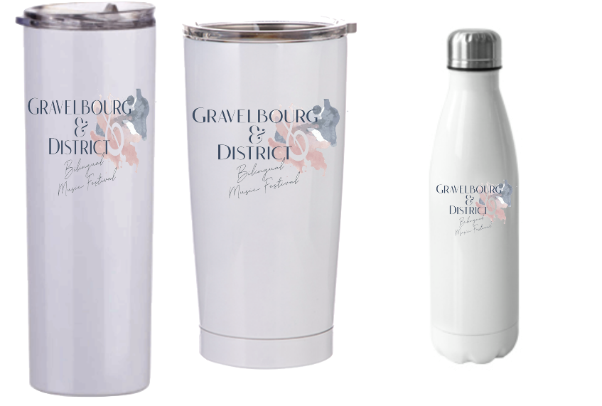
Simply complete the attached order form, email it & e-transfer.
Merchandise orders will be filled upon receipt of your e-transfer payment to: gravelbourg.music.festival@gmail.com
All Sales Final
Merchandise Order Form
Your Full Name: | Click or tap here to enter text.
Select the Merchandise you want to order & indicate the quantity of each item: | Merchandise:  ☐ Coffee mug ($20)  ☐ Bag ($30)  ☐ Slim Insulated Travel mug ($35)  ☐ Plump Insulated Travel mug ($35)  ☐ Water Bottle ($35) | Quantity:  Click or tap here to enter text.  Click or tap here to enter text.  Click or tap here to enter text.  Click or tap here to enter text.  Click or tap here to enter text.
Enter your email address: | Click or tap here to enter text.
Enter your phone number: | Click or tap here to enter text.
Enter your shipping address:  (not required if Picking up your order) | Click or tap here to enter text.
Please Select your preference Curb side Pick-up or Delivery: | ☐ Curb side Pick-up  ☐ Ship to the mailing address listed above  (note additional costs for shipping).
Canada Post Shipping Rates:  (please add this cost to your total order to cover the cost of shipping) | ☐ Within Gravelbourg $15.00  ☐ Outside Gravelbourg $17.00
Additional Information/Notes | Click or tap here to enter text.

If you choose Curb side Pick-up, you will be contacted by email or telephone to arrange a date, time & place for your curb-side Pick-up
Thank-you
We appreciate your support!

